Appendices
Appendix 1 – Medication Reconciliation Formulary (English version)
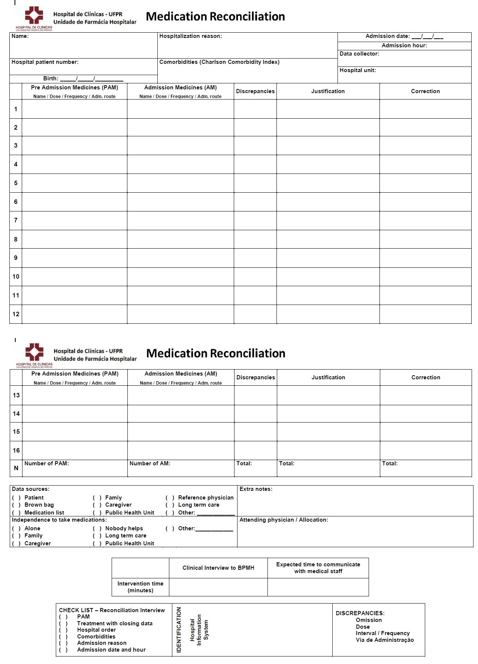
Appendix 2 – Medication History Check List (English version)
